FACULTY EVALUATION
Programme Name: SBVP ALUMNI MASTERCLASS Online s Module 2 Zambia (4th May 2026 - 8th May 2026)
Session: Social impact measures and planning
Faculty Name: Kingsley Kalusha
No. of Respondents: 13
No. of Participants: 13
Evaluation Parameter | (%) Individual Score | (%) Programme Average
Punctuality (Commencement and Completion of Sessions) | 94 | 95
How well do you understand the core concepts presented? | 83 | 88
Rate your confidence in applying the new skills learnt | 80 | 85
Degree of Faculty preparedness for the sessions | 91 | 93
Content and methodology of the program | 92 | 95
Quality of class and group discussions | 89 | 91
The information presented in the course is relevant to my work (ministry) | 92 | 95
Average scores | 89 | 92

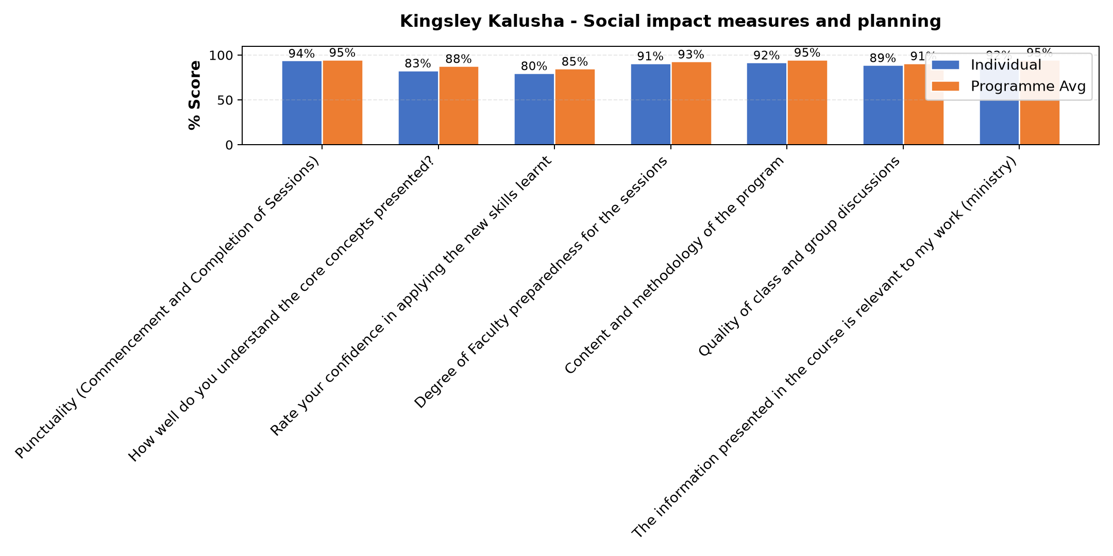

Comments & Feedback
- • I am not directly involed in project
- • No barriers will prevent me from applying what I have leant
- • The Monthly returns paying to some government entities.
- • My effort
- • I need to study it more
- • Network challenges
- • Congregation leadership
- • The time where the session is please. It come without pre preparedness hence missing some sessions because one has to teach.
- • Leadership
SUBMITTED THROUGH:
SBS Evaluation Automation System

